

1 | Personal Information

NAME | Nakul Shrivastava
DEGREE / MAJOR | B.Tech, Computer Science and Engineering (Specialisation: Bioinformatics)
COLLEGE / UNIVERSITY | Vellore Institute of Technology (VIT), Vellore
YEAR OF GRADUATION | 2030 (expected)
EMAIL | [ add your email address ]
PHONE | [ add your phone number ]
LINKEDIN / PORTFOLIO WEBSITE | www.linkedin.com/in/nakul-shrivastava-091464423

2 | Career or Higher Studies

FIELD I WANT TO WORK OR STUDY IN
Computational biology and bioinformatics: using programming and mathematical models to understand living systems.
SHORT-TERM GOAL (1–2 YEARS)
Build a solid base in Python, object-oriented programming, data structures and statistics, and use it in projects on biological data. I also want to take part in more hackathons and find a first internship or lab assistantship in bioinformatics.
LONG-TERM GOAL (5 YEARS)
Work in a computational biology or bioinformatics team, building models and tools that help researchers understand biological systems, with an MS in the same field as an option.

3 | Personal Statement (75 – 100 words)

I am a first-year B.Tech Computer Science student at VIT, specialising in Bioinformatics. I like the moment when an equation or a design turns into something that behaves like the real world, which is why I enjoy using code and mathematics to understand living systems. So far I have modelled how cell shape affects nutrient uptake, built a 3D reference model of a water-leak detection rig, and made a browser game from scratch. I am still learning, and I want to keep growing through projects, hackathons and internships. My goal is to work where computation and biology meet.

4 | Education

DEGREE | Bachelor of Technology: Computer Science and Engineering (Bioinformatics)
INSTITUTION | Vellore Institute of Technology (VIT), Vellore
YEAR | 2026 – 2030 (expected); currently in the first year
IMPORTANT COURSES RELATED TO MY CAREER / HIGHER STUDIES
CODE | COURSE | WHY IT MATTERS FOR MY CAREER
BABIT101 | Biochemistry | Chemistry of the molecules and reactions inside living cells
BABIT103 | Cell and Molecular Biology | How cells work: DNA, RNA and proteins, the data bioinformatics analyses
BABIT202 | Fundamentals of Bioinformatics | Core methods: sequence analysis, databases and biological data tools
BABIT304 | Structural Bioinformatics | Predicting and studying 3D protein structure
BABIT306 | Systems Biology | Modelling whole biological systems, linked to my nutrient-uptake project
BACSE104 | Structured and Object-Oriented Programming | Strong programming base for writing research tools
BACSE105 | Data Structures and Algorithms | Efficient handling of large biological datasets
BACSE202 | Database Systems | Storing and querying genomic and protein data
BACSE205 | Fundamentals of AI and Machine Learning | Machine learning for biological prediction and classification
BAMAT101 | Multivariable Calculus and Differential Equations | Maths behind my ODE modelling project
BAMAT205 | Discrete Mathematics and Linear Algebra | Foundation for algorithms, graphs and data analysis
BAMAT207 | Probability and Statistics | Interpreting experimental and biological data correctly

PROJECT TITLE | Leak Finder: Real-Parts Reference Model for a Water-Leak Detection Rig
COURSE / SUBJECT | MDP (group project)
MY ROLE | All of the computing part, the 3D reference model, and every file in the package except the project charter
STATUS | Reference design package R1, issued 20 October 2026 (digital design; not yet built)

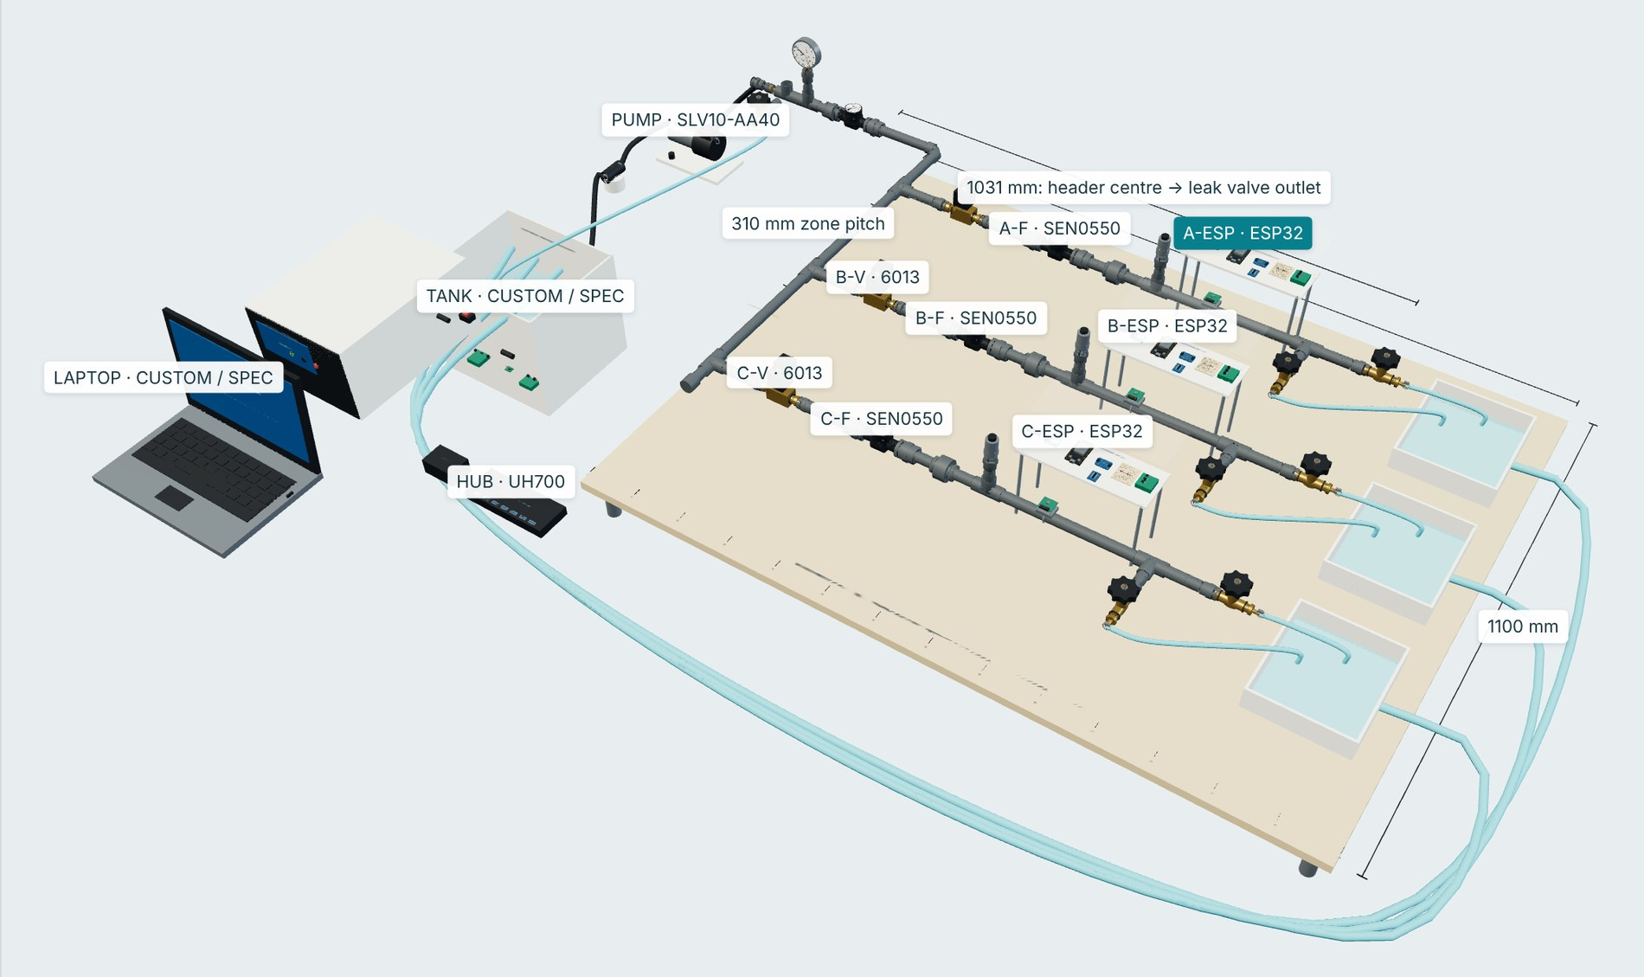
Figure 1. Interactive 3D reference model of the Leak Finder test rig: three zones (A, B, C), pump and tank, laptop and USB hub.
DESCRIPTION OF THE PROJECT
Water networks lose a large share of their supply to leaks, and the two usual detection methods fail in opposite ways. Flow analysis shows that a zone is leaking but cannot say where; acoustic monitoring hears leaks but raises false alarms from pumps and ordinary water use. Leak Finder combines flow, pressure and clamp-on vibration sensing so that each stream can check the others, and reports one verdict per zone: normal, suspected or confirmed.
I made the interactive 3D reference model of a 1.4 m × 1.1 m wet test board with three zones, together with a bill of materials, wiring and plumbing schedules and a 41-page build guide. A test rig like this is needed because a real network can never give a leak of known size, place and time.
The design rests on three ideas: the system knows pump, valve and demand state, so it can explain noise instead of alarming on it; each acoustic node learns the normal sound of its own pipe, so no labelled leak recordings are needed; and when a leak is suspected, zone valves close in sequence while inlet flow is watched, to narrow down the location.

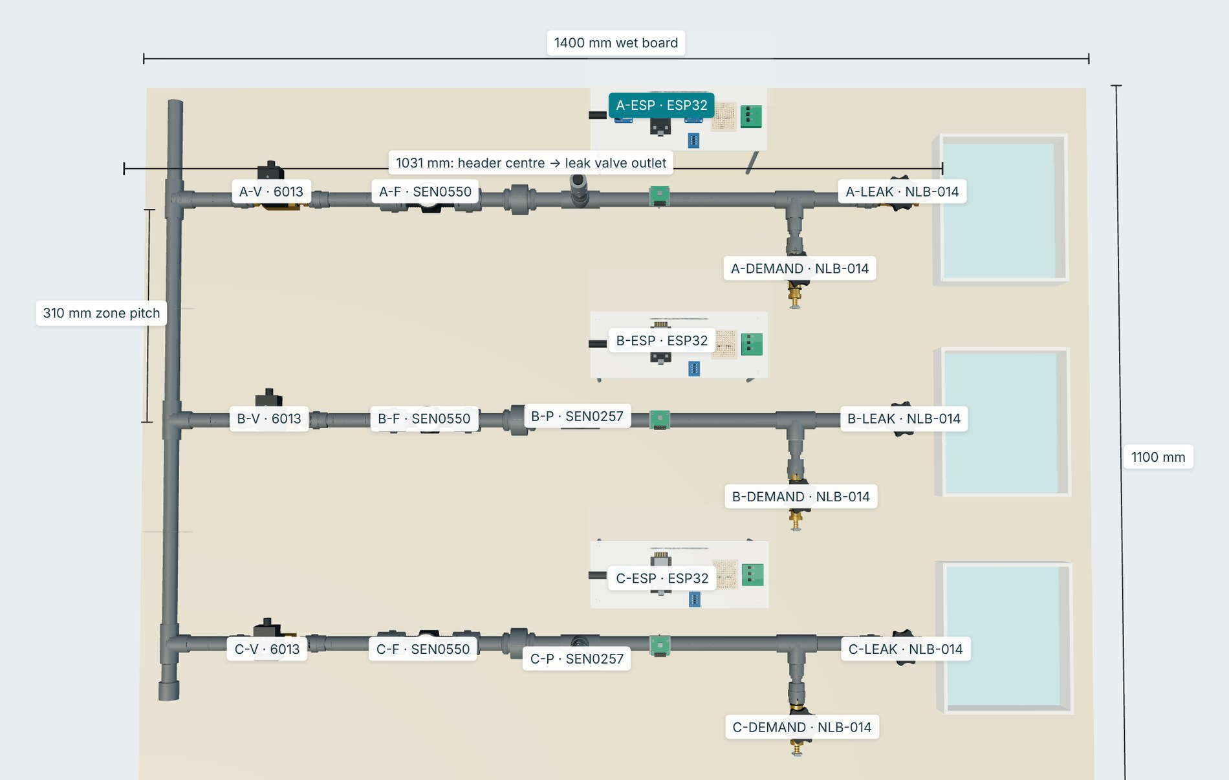  Figure 2. Top view: zones A–C, valves, flow and pressure sensors, ESP32 nodes. |  | 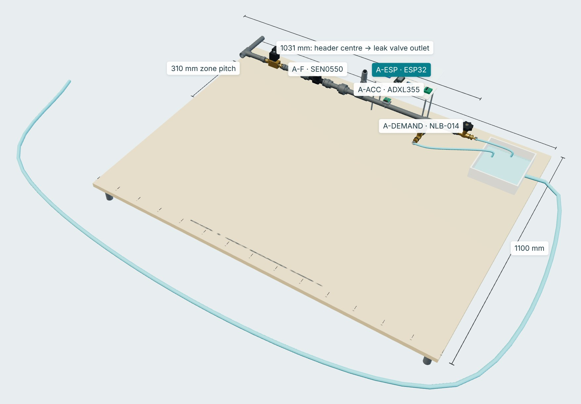  Figure 3. One zone and its pipe joints.

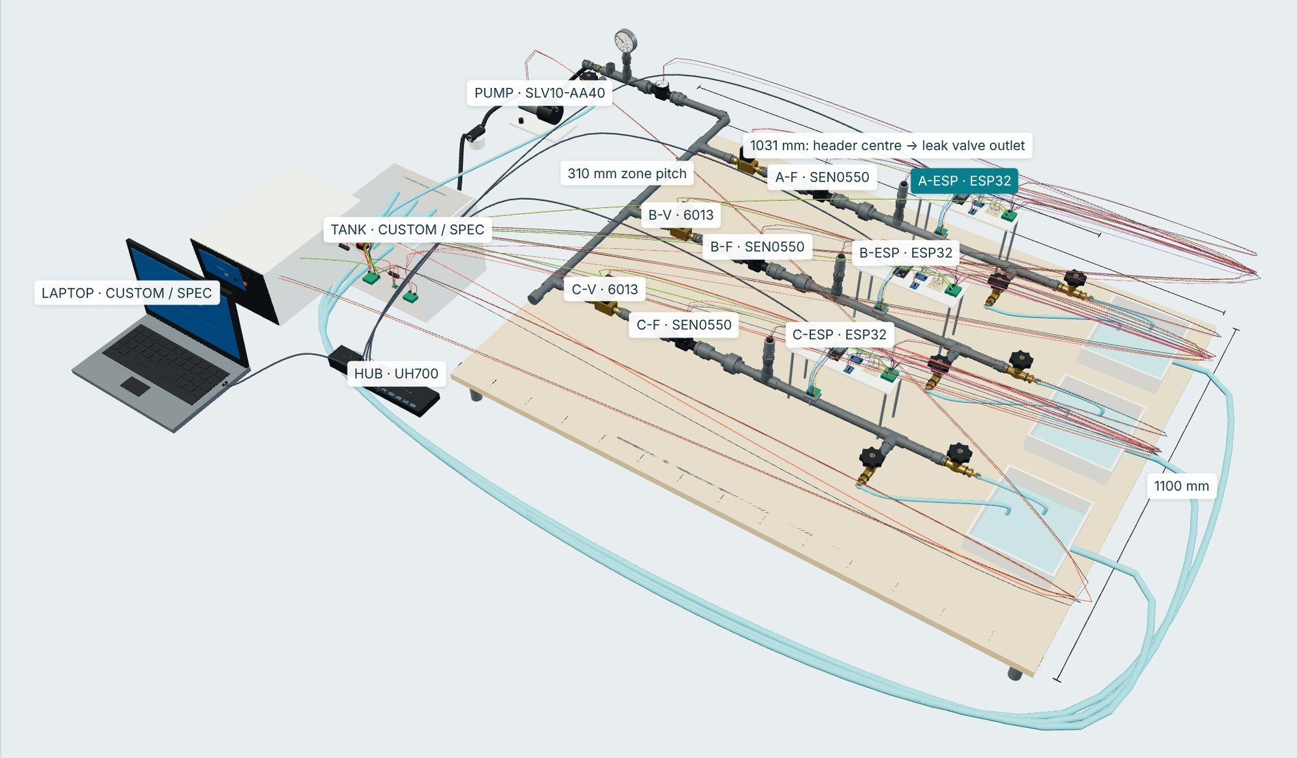  Figure 4. Electrical harness switched on. |  | 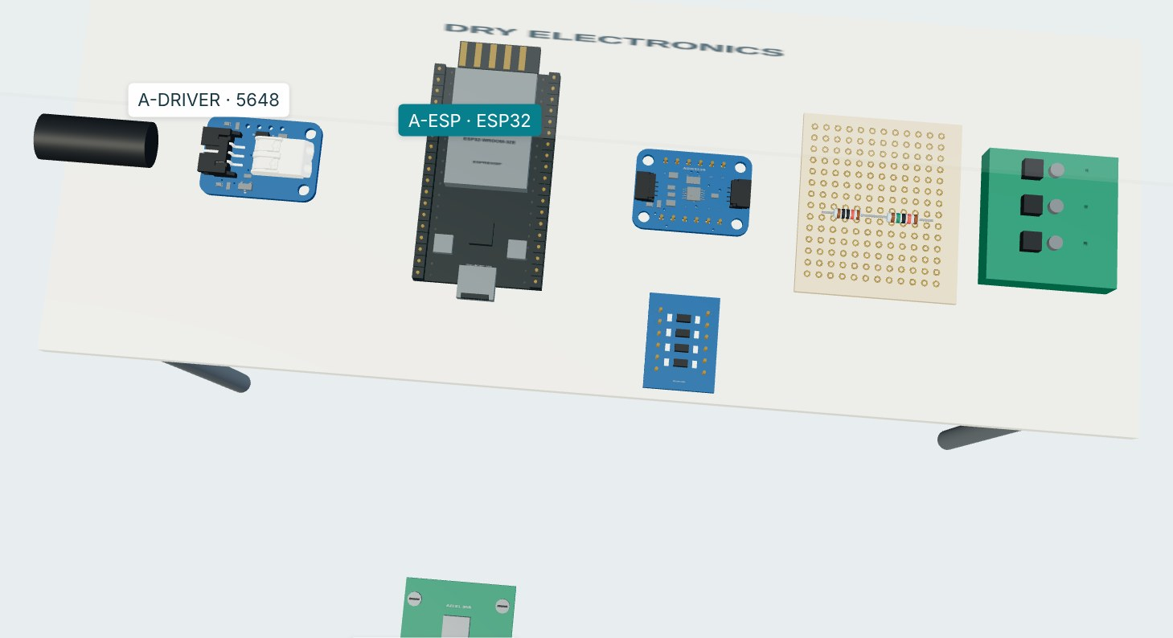  Figure 5. Local electronics: ESP32, ADC, valve driver, level converter.
WHAT THE PACKAGE CONTAINS
ITEM | DETAIL
3D reference model | Interactive HTML viewer that works offline, plus a GLB 3D file; 303 component and material instances
Connection schedules | 135 electrical connection records and 201 plumbing joint records, with CSV tables
Hardware per zone | ESP32 node, ADXL355 accelerometer, SEN0550 flow sensor, SEN0257 pressure sensor, 12 V isolation valve
Documentation | Bill of materials, six wiring diagrams, 41-page build guide, validation report
Status and limits. This is a digital reference design. It has passed the package's own consistency checks (unique IDs, valid endpoints, separate earth connection), but it has not been built or bench-tested, and no leak-detection performance is claimed. Fit checks are listed as open items.
SKILLS USED
3D system modelling Electrical and plumbing schematics ESP32 pin mapping Sensors: flow, pressure, vibration Bill of materials Technical documentation Programming and system logic
PROJECT TITLE | Mathematical Modelling of Nutrient Uptake in Cells
COURSE / SUBJECT | Multivariable Calculus and Differential Equations (BAMAT101)
FORMAT | Mathematics assessment: 22-slide presentation with an Octave solution
DESCRIPTION OF THE PROJECT
Does a long, thin cell take up nutrients faster than a round cell of the same volume? I modelled passive entry through the membrane, assuming the nutrient mixes quickly inside, as a differential equation and solved it by hand and symbolically in GNU Octave. Three shapes were then compared at the same permeability.
V dC/dt = PS (C_{out} − C) → C(t) = C_{out} [ 1 − e^{−βt} ], β = PS / V
Nutrient balance, and its solution with C(0) = 0

1  Ask the question | 2  Build the model | 3  Write the ODE | 4  Solve it | 5  Choose values | 6  Compare uptake

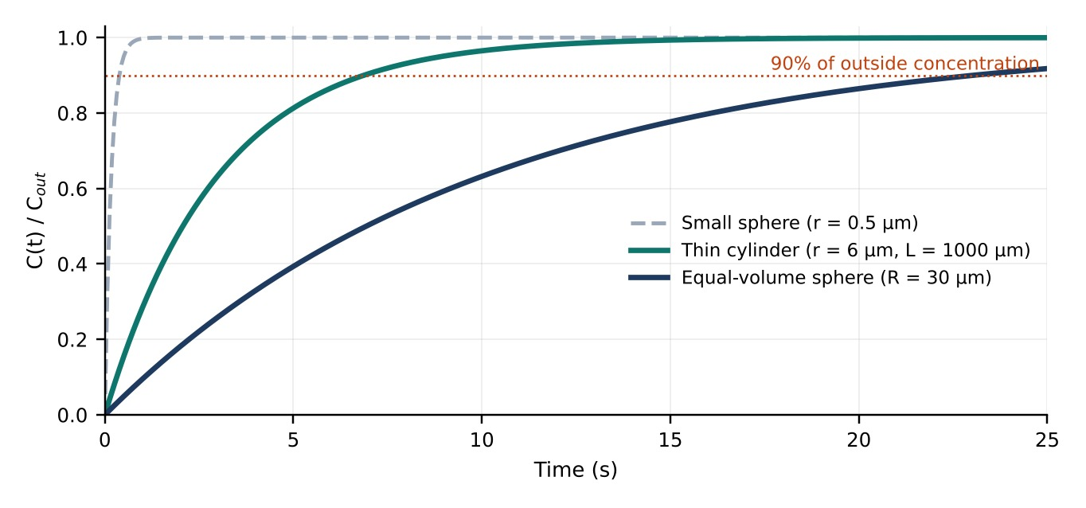  Figure 1. Concentration inside each cell over time. |  | TIME TO REACH 90% OF OUTSIDE CONCENTRATION  0.38 s Small sphere (r = 0.5 µm)  S/V = 6.000 µm⁻¹  6.87 s Thin cylinder (r = 6 µm, L = 1000 µm)  S/V = 0.335 µm⁻¹  23.03 s Equal-volume sphere (R = 30 µm)  S/V = 0.100 µm⁻¹  Same volume, same permeability: the thin cylinder is 3.35× faster than the sphere.

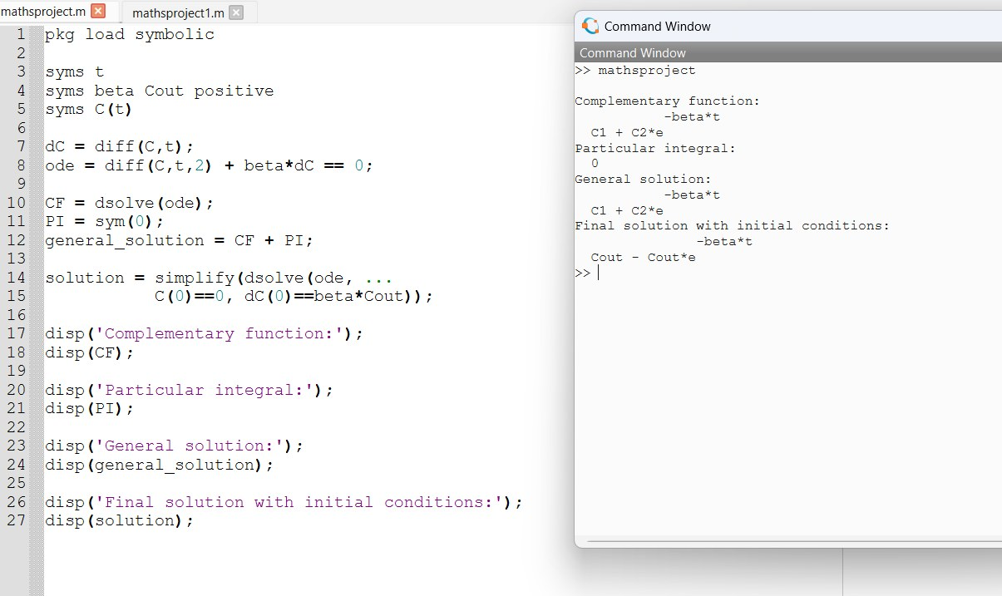  Figure 2. My Octave script and its symbolic output. |  | 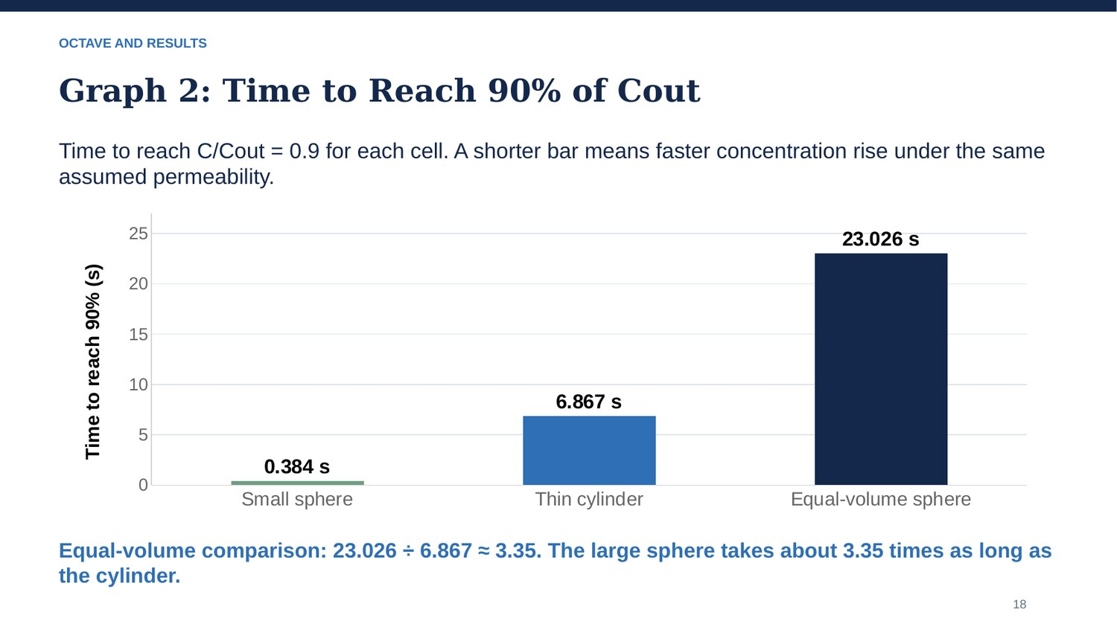  Figure 3. Time to reach 90%, from the presentation.

Limits I state in the project: the cell shapes and the permeability (P = 1 µm/s) are illustrative values, not measurements; the model has no consumption inside the cell and no variation with position, so it shows a trend, not real biological times.
Ordinary differential equations Mathematical modelling GNU Octave Surface-area-to-volume analysis Interpreting graphs Class presentation
Declared in the presentation: AI assisted with explanations, code and conceptual artwork.
PROJECT TITLE | Ninja Slice: a Browser Arcade Game
COURSE / SUBJECT | Self-learning project in web development (HTML, CSS, JavaScript)
FILES | index.html, style.css, game.js and a README; no installation or build step needed
DESCRIPTION OF THE PROJECT
Ninja Slice is a fruit-slicing game for the browser. The player holds and drags a mouse or finger to swing a blade through flying fruit and must avoid the bombs. It runs on an HTML5 canvas with all the game logic written in plain JavaScript, and it works with both mouse and touch.
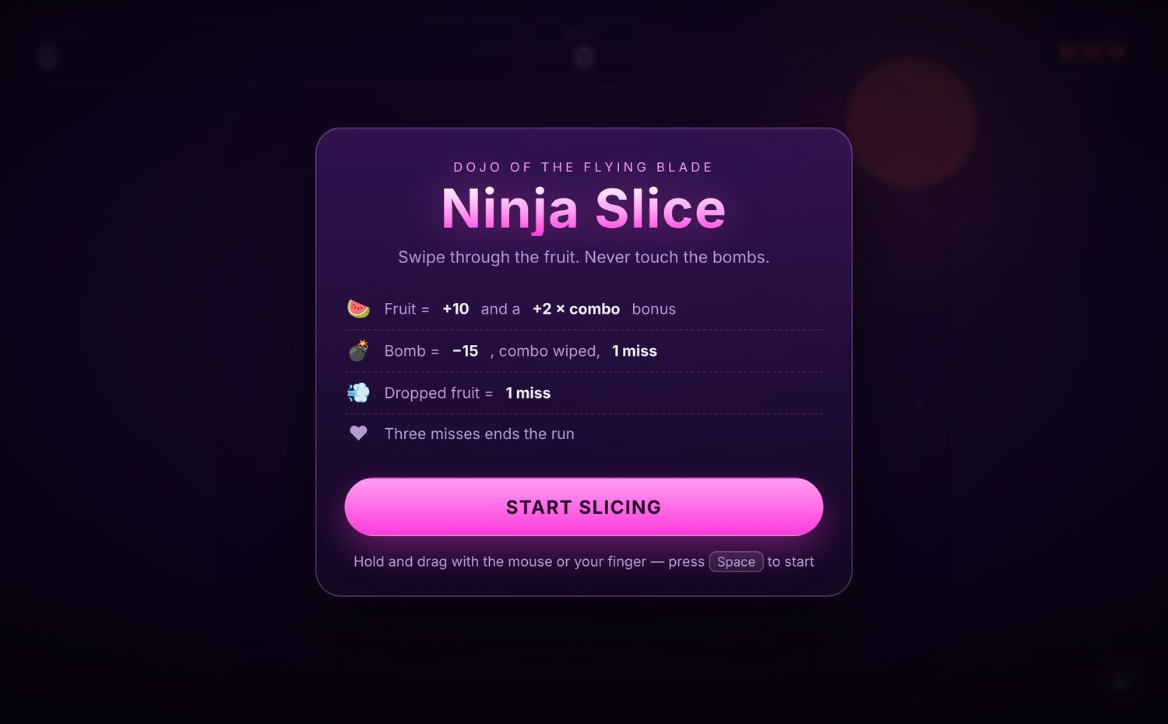  Figure 1. Start screen with the rules. |  | 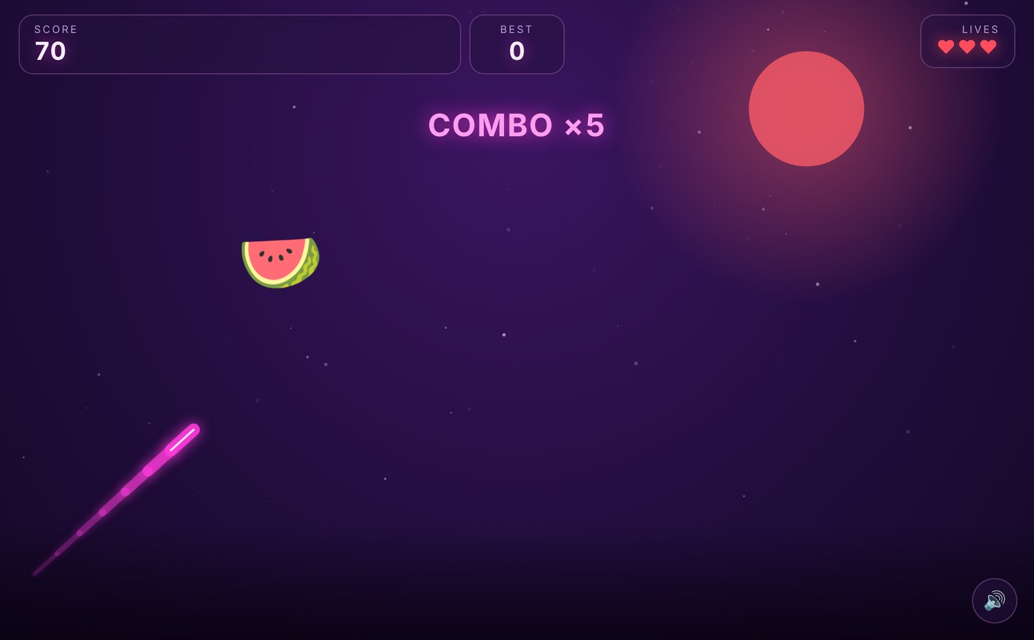  Figure 2. Gameplay: blade trail, combo counter, lives.
SCORING RULES, AS IMPLEMENTED
EVENT | EFFECT
Slice a fruit | +10 points plus a +2 × combo bonus; the combo grows by one
Slice a bomb | −15 points, the combo is reset and it counts as one miss
Fruit falls off screen | One miss; the combo is not reset
Three misses | The run ends; the score is compared with the saved best score
HOW IT WORKS
▪ Fixed-step physics. The simulation runs at 60 steps per second while drawing runs separately, so the game behaves the same on 60, 120 or 144 Hz screens.
▪ Flying arcs. Fruit launches with random speed and drift and is pulled down by gravity (0.35 px per frame²), so each one follows a real parabola.
▪ Reliable slicing. The game tests the line the blade has swept (its last 14 positions) against every fruit, so fast swipes still register.
▪ Rising difficulty. Items appear faster as the score grows: the gap between launches shrinks from 34 frames to a minimum of 14.
▪ Details. Sounds are synthesised with the Web Audio API, so no audio files are needed, and the best score is saved in the browser.
SKILLS USED
HTML5 Canvas CSS layout and theming JavaScript Game loop and physics Web Audio API Pointer and touch input README documentation
PROJECT TITLE | Green Energy and Green Fuels: From Fossil Fuels to Green Cells
COURSE / SUBJECT | Technical English Communication (BAENG101P), Semester 1
TEAM | Two-person presentation with Anwesh; both of us presented
FORMAT | 9-slide presentation with speaker notes
DESCRIPTION OF THE PROJECT
Our talk asks why the world needs more energy every year and why that energy should come from renewable, low-emission sources. It moves from the problem (rising demand, the costs of coal, oil and gas) to the answer (solar, wind, fuel cells and biogas), explains why the switch took so long, and ends with how green energy already helps villages, farms and homes.
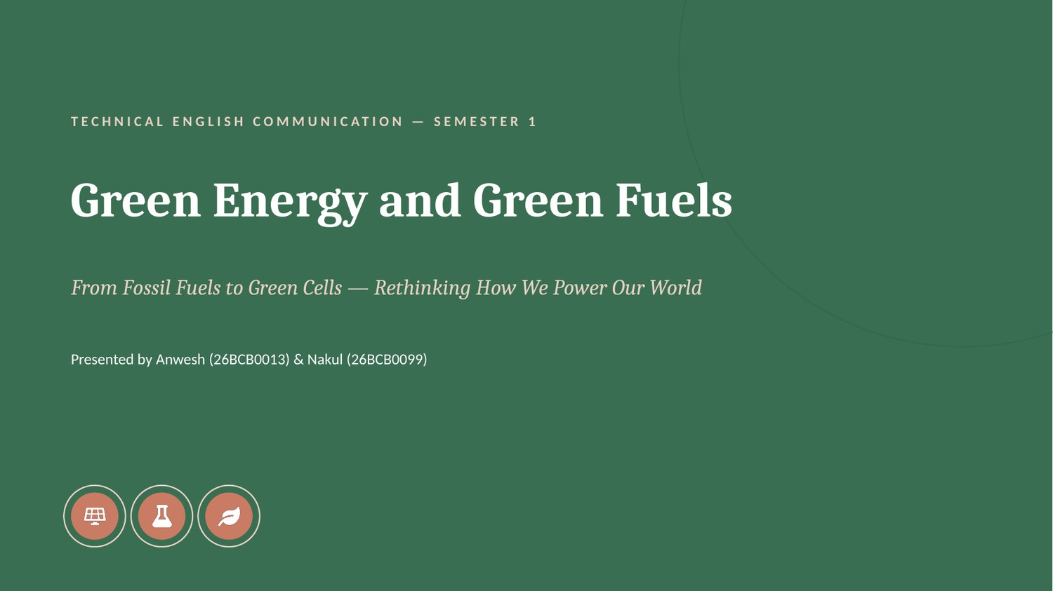  Figure 1. Title slide. |  | 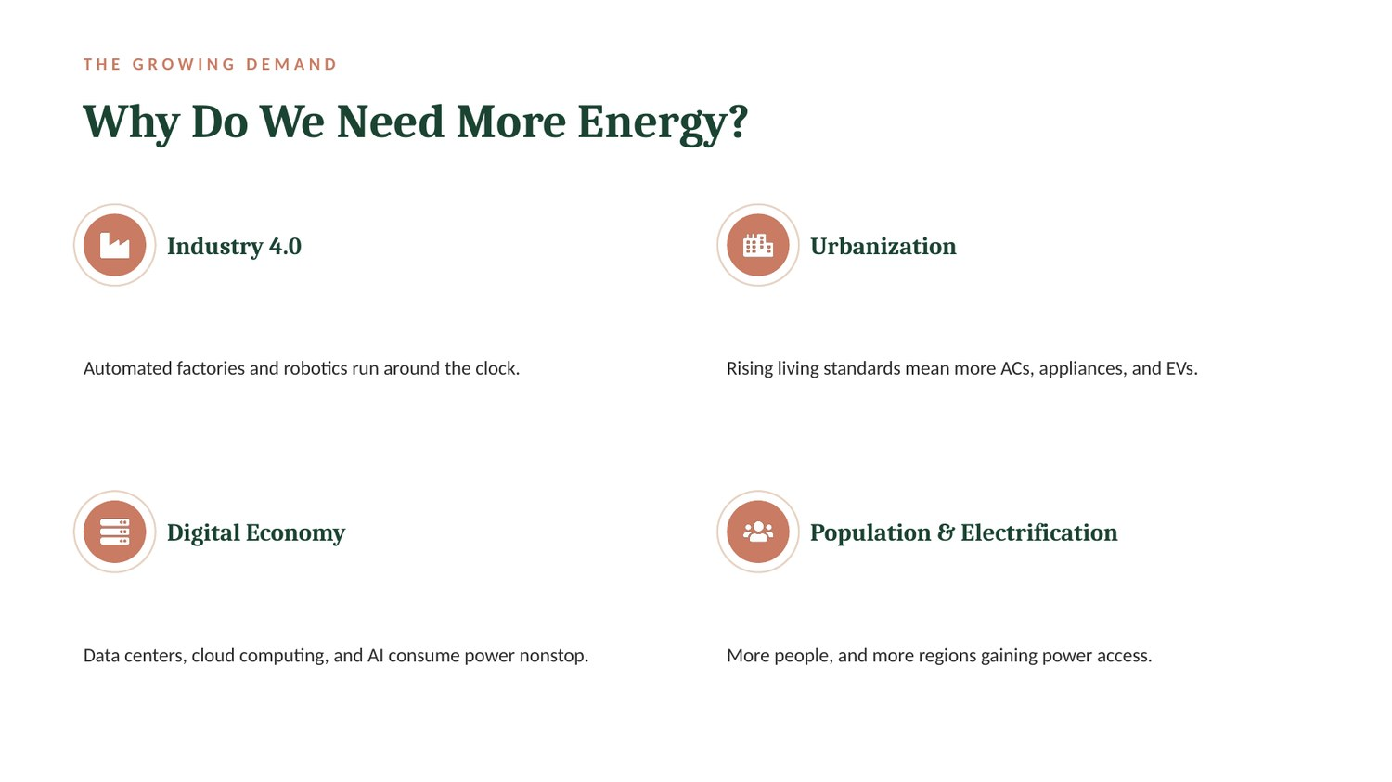  Figure 2. Why do we need more energy?

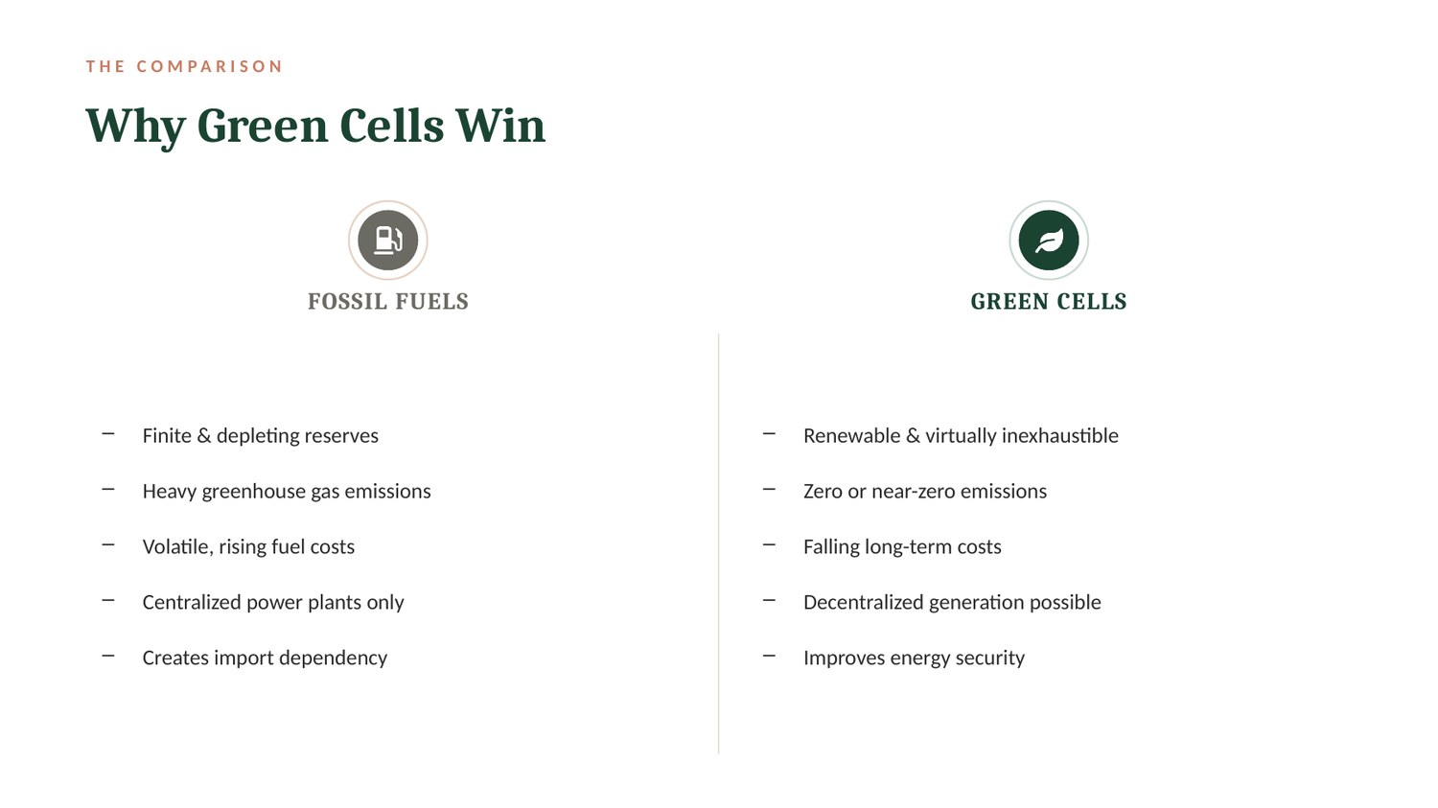  Figure 3. Why green cells win. |  | 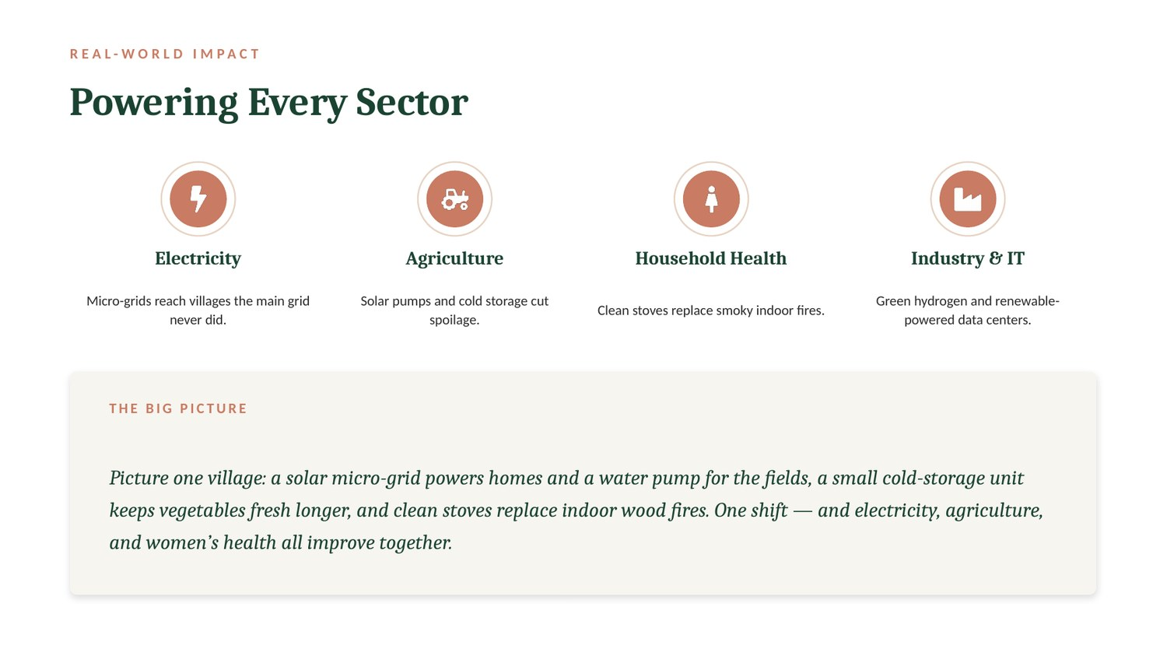  Figure 4. Powering every sector.
HOW THE ARGUMENT IS BUILT
SLIDES | POINT MADE
2 – 3 | Demand is rising (Industry 4.0, urbanisation, the digital economy, population); fossil fuels bring emissions, air pollution and finite reserves
4 – 5 | Green cells (solar PV, wind, fuel cells, biogas) compared side by side with fossil fuels
6 – 7 | Why adoption was slow (cost, storage, existing infrastructure) and what is next: perovskite solar cells, better batteries, green hydrogen, smart grids
8 – 9 | Real-world impact on electricity, agriculture, household health and industry; closing message
SKILLS USED
Research and source selection Structuring an argument Slide design Speaking to an audience Writing speaker notes Teamwork

6 | Internship / Work Experience

No internship or work experience yet. As a first-year student, I am looking for an internship in bioinformatics or computational biology where I can apply my modelling and programming skills and learn from experienced mentors.

7 | Skills

TECHNICAL SKILLS
▪ Programming languages: Python, C++, JavaScript, HTML, CSS
▪ Tools and software: GNU Octave (symbolic solving and plotting)
▪ Technical areas: mathematical modelling with ODEs; 3D modelling and technical documentation; electronics basics (ESP32, sensors, wiring); web game development
SOFT SKILLS
▪ Communication
▪ Leadership
▪ Teamwork
▪ Problem Solving
▪ Time Management
OTHER SKILLS
▪ Scientific presentations and slide design
▪ Technical writing and project documentation
▪ Reading datasheets and bills of materials
▪ Explaining technical ideas in plain language

8 | Achievements / Awards

▪ Built a complete 3D reference model of the Leak Finder test rig: 303 components, 135 electrical connections and 201 plumbing joints.
▪ Developed Ninja Slice, a playable browser game with sound, a combo system and a saved best score.
▪ Solved the nutrient-uptake model in Octave and showed a 3.35× difference in uptake time between two cell shapes.
▪ Co-presented a nine-slide talk on green energy in Technical English Communication.
▪ Took part in my first hackathon (no prize; I went to learn and gain experience).

9 | Certifications / Training

CERTIFICATION | CS50's Introduction to Programming with Python (CS50P)
INSTITUTION | Harvard CS50 (online)
YEAR | 2026 (in progress)

10 | Extracurricular Activities

ACTIVITY | 1. College-level badminton matches
ROLE | Participant / player
SKILLS GAINED | Teamwork, discipline, fitness, handling competitive pressure

ACTIVITY | 2. Marathons
ROLE | Participant
SKILLS GAINED | Endurance, goal setting, consistency

ACTIVITY | 3. Workshops
ROLE | Participant
SKILLS GAINED | Hands-on learning, new technical and practical skills, networking

11 | Reflection

What achievement are you most proud of?
▪ Turning a biology question into something I could calculate.
▪ In the nutrient-uptake project I went from a simple question (does cell shape change how fast nutrients get in?) to an equation, an Octave check and a graph that answered it.
What important skills did you develop during college?
▪ Mathematical modelling and solving differential equations.
▪ Basic Python, Octave and JavaScript, and reading graphs critically.
▪ Explaining technical ideas in plain language.
▪ Working on Leak Finder taught me that a design is not finished until every wire and pipe joint is accounted for.
What challenges did you overcome?
▪ My first idea for the maths project, Turing patterns, was too advanced for me to explain properly, so I switched to a simpler model that I could understand from first principles.
▪ I learnt to choose a problem I can fully explain, and I am still learning to balance several demanding first-year courses.

